Ex4-Create a simple cloud software application for Library book reservation system for SIMATS library using any Cloud Service Provider to demonstrate SaaS include the necessary fields such as Title of the book, author, publications, Year, edition, no of copies, Rack no, status (taken/returned) etc.

PROCEDURE:

Step1 : Create an application name as Easylearn

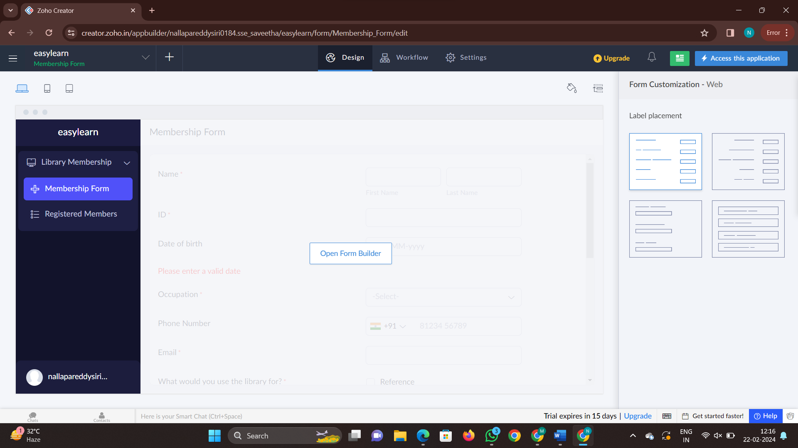

Step 2 : now create a new form and name it as details for membership

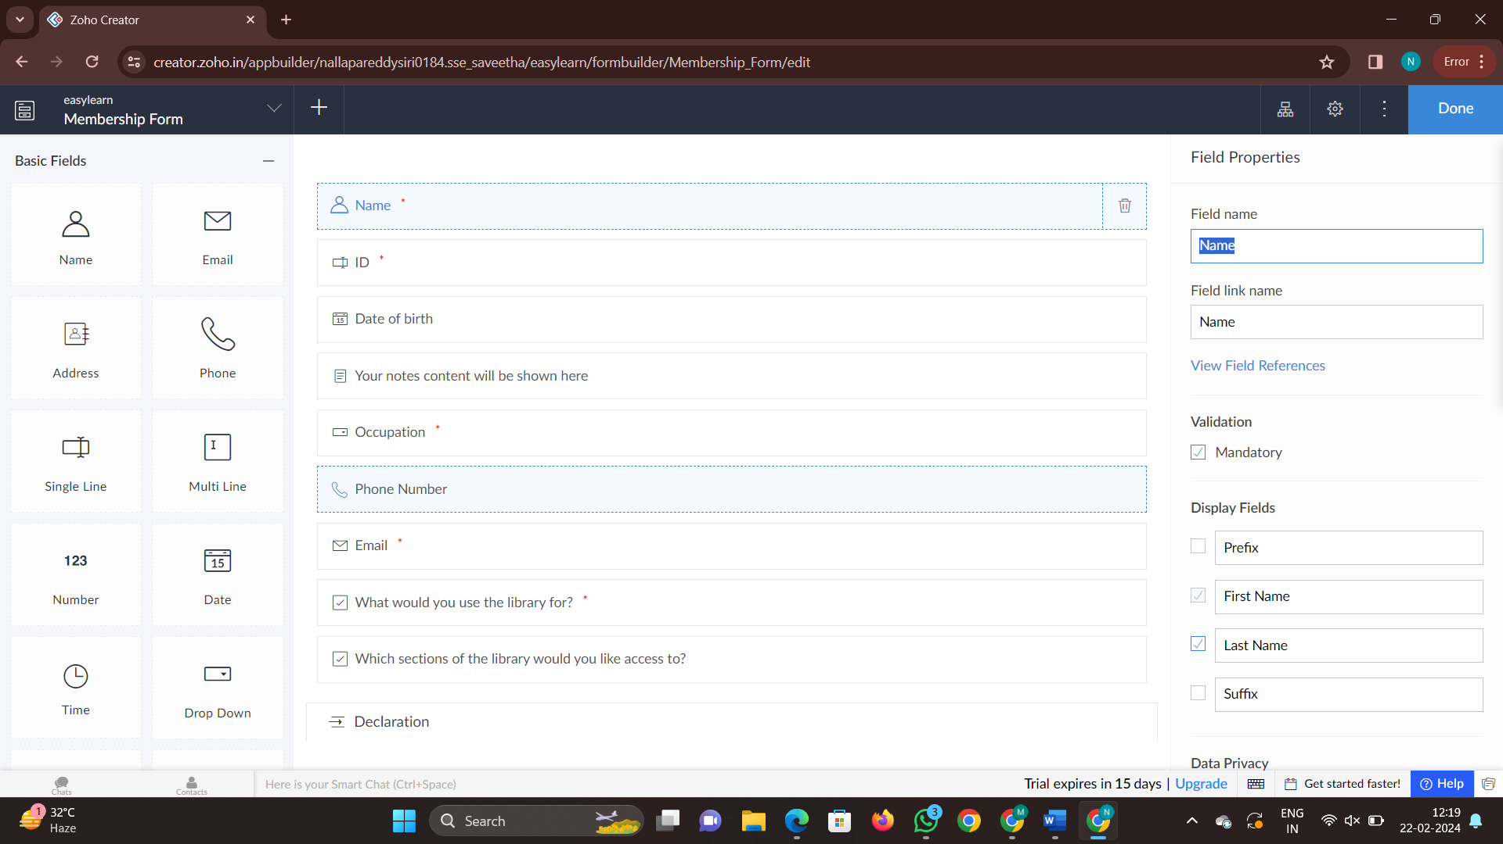

Step 3: Now create another new form as details and fill the contents in the form

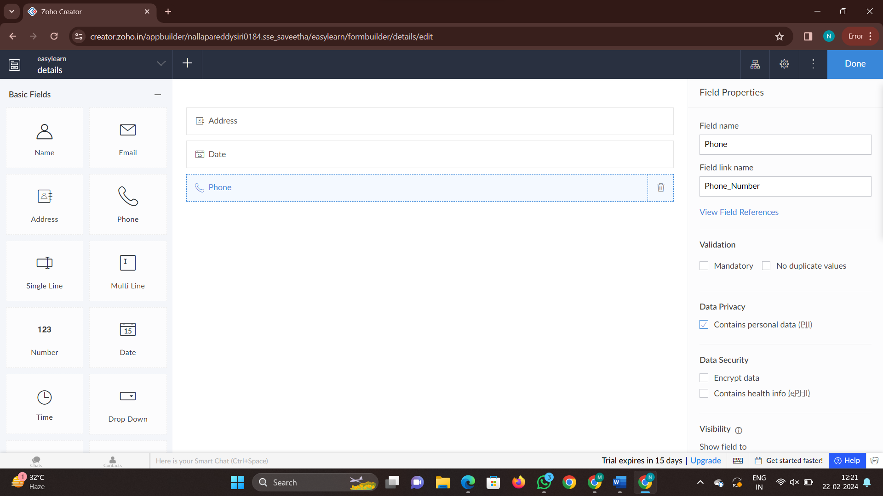

Step 4: Now click on done and check all the contents are suitable or not

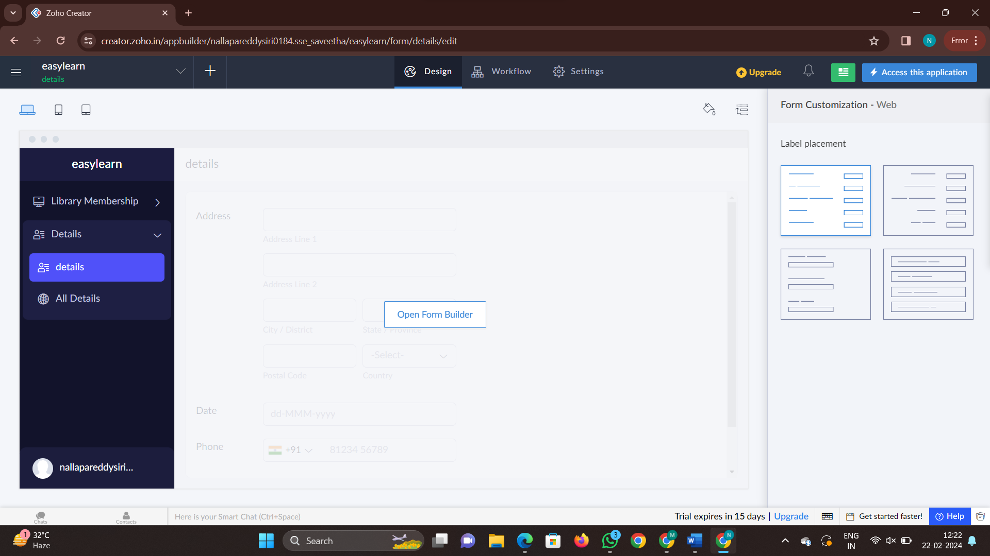

Step 5: Now click on access this application

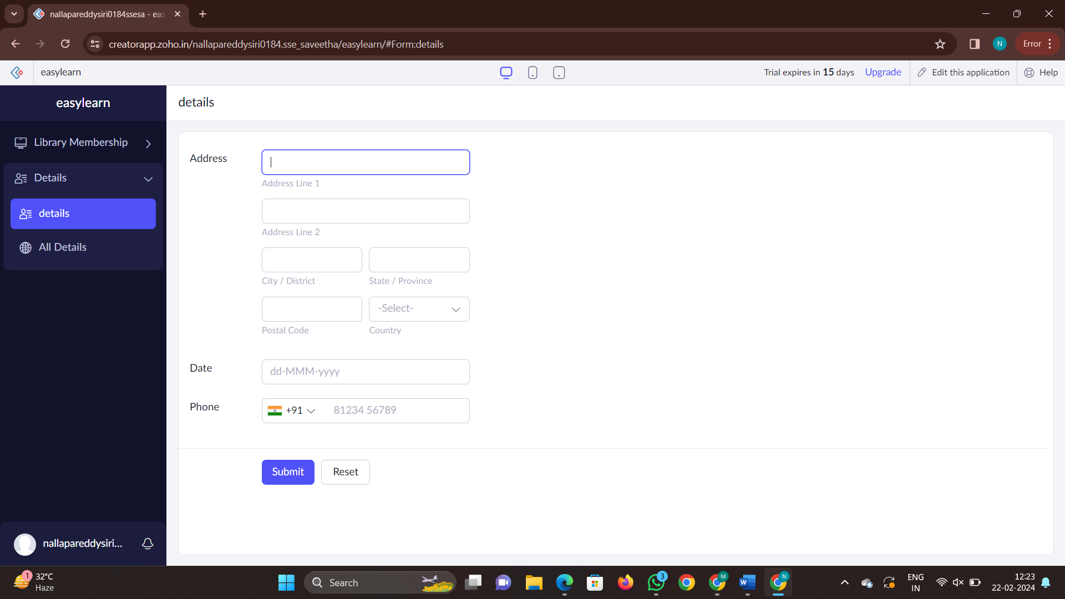

Step 6: now fill the details with dummy values and check the report

